ACTIVITY 2 : DATA COLLECTION AND EXTRACTION FROM DATABASE:

Data collection is the process of gathering and measuring information on variables of interest, in an established systematic fashion that enables one to answer stated research questions, test hypotheses, evaluate outcomes and generate insights from the data.

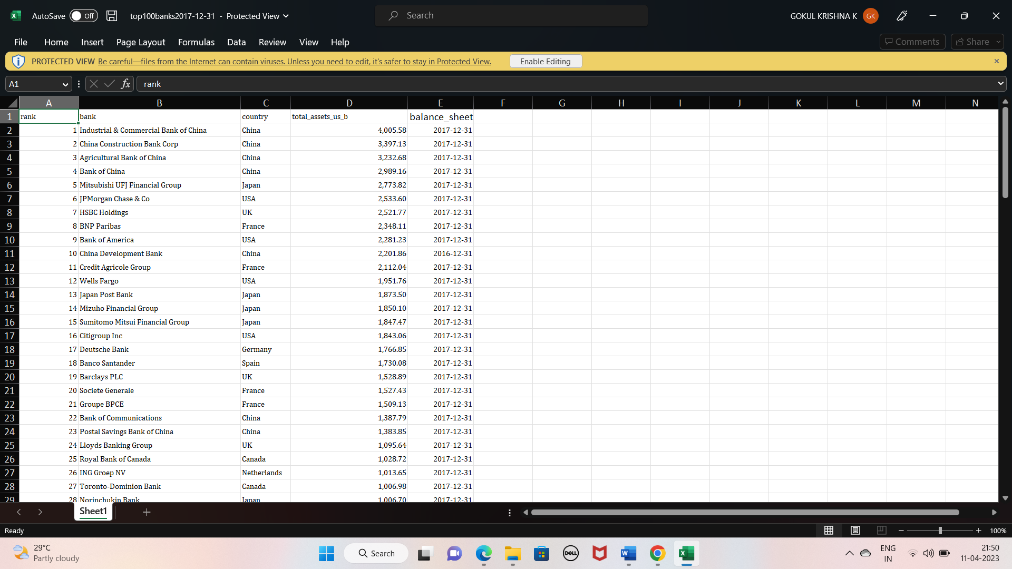

: Understand the data Data contains all the meta information regarding the columns described in the CSV files Column Description of the Dataset: 1. bank: Name of the bank 2. Country: In which country the bank is operating 3. Total Assest: Total assets of the banks 4. Rank : Rank of the bank among the world 5. landmass : Under which continent the bank belongs to.

2.STORING DATA IN DB AND PERFORM MY SQL OPERATIONS:

